# **Name: Abdurrahman Qureshi**

# **Roll No: 210451**

Practical No: 5

**1) WAP in JAVA which will print factorial of a number.**

**CODE:**

import java.util.Scanner;

public class Main {

public static void main(String[] args){

Scanner sc = new Scanner(System.in);

System.out.print("Enter Number: ");

int ogNum = sc.nextInt();

int fact = 1;

int num = ogNum;

while (num != 0) {

fact = fact * num;

num = num - 1;

}

System.out.println("Factorial : " + ogNum + "! = " + fact);

}

}

**OUTPUT:**

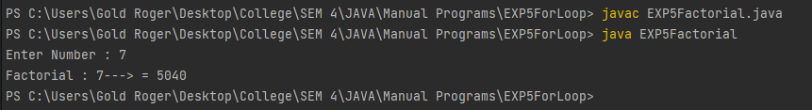

**2) WAP in JAVA Which to print Fibonacci from 1 to n**

**CODE:**

import java.util.Scanner;

public class Main {

public static void main(String[] args) {

Scanner sc = new Scanner(System.in);

System.out.print("Enter Range : ");

int range = sc.nextInt();

long f1 = 0L;

long f2 = 1L;

long f3;

System.out.print("Fibonacci Series : " + f1 + " " + f2);

for (int i = 0; i <= range; i++) {

f3 = f1 + f2;

System.out.print(" " + f3);

f1 = f2;

f2 = f3;

}

}

}

**OUTPUT:**

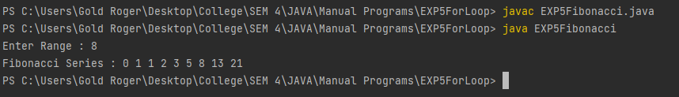

**3) WAP in JAVA Which to check prime or not**

**CODE:**

import java.util.Scanner;

public class Main {

public static void main(String[] args) {

Scanner sc = new Scanner(System.in);

System.out.print("Enter Number : ");

int num = sc.nextInt();

int count = 0;

for (int i = 1; i<= num; i++) {

if (num%i == 0) {

count++;}}

if (count == 2) {

System.out.println(num + " is a Prime Number");

} else {

System.out.println(num + " is not a Prime Number");}}}

**OUTPUT:**

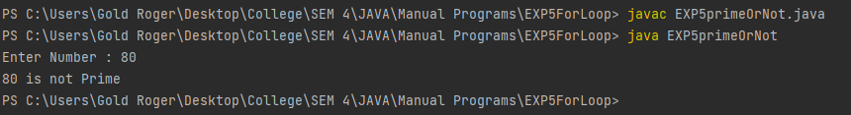 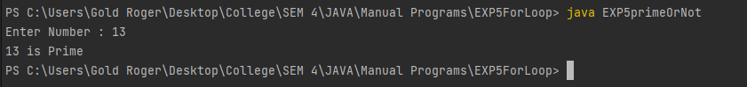

**4) WAP in JAVA Which will print prime from 1 to n**

**CODE:**

import java.util.Scanner;

public class Main {

public static void main(String[] args) {

Scanner sc = new Scanner(System.in);

System.out.print("Enter Range : ");

int n = sc.nextInt();

int count = 0;

System.out.print("Prime Series : ");

for (int i = 1; i <= n; i++) {

count = 0;

for (int j = 1; j<= i; j++) {

if (i%j == 0) {

count++;

}}

if (count == 2) {

System.out.print(i + " ");

}

}

}

}

**OUTPUT:**

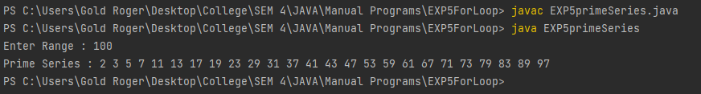

**5) WAP in JAVA to display multiplication table of N**

**CODE:**

import java.util.Scanner;

public class EXP5TableOfN {

public static void main(String[] args) {

Scanner sc = new Scanner(System.in);

System.out.print("Enter Number : ");

int num = sc.nextInt();

System.out.println("Multiplication Table of " + num + ": ");

for (int i = 1; i <= 10; i++) {

System.out.println(num + " * " + i + " = " + (num * i));

}

}

}

**OUTPUT:**

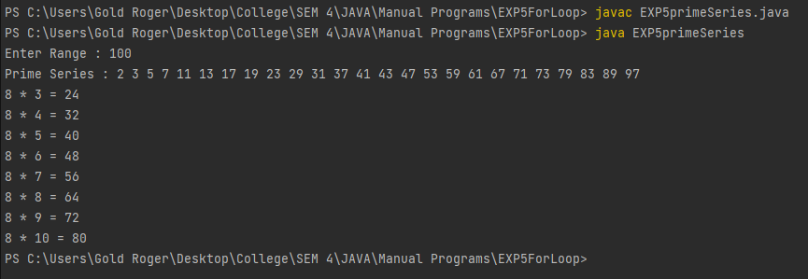

**6) WAP in JAVA to use command line arguments**

**CODE:**

import java.util.Scanner;

public class EXP5cmdArgs {

public static void main(String[] args) {

System.out.println("Printing CommandLine Arguments : ");

for (int i = 1; i < args.length; i++) {

System.out.println("Args[" + i + "] = " + args[i]);

}

}

}

**OUTPUT:**

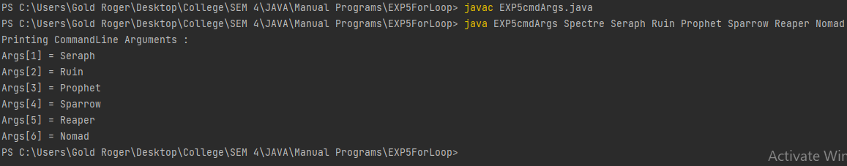

**7) WAP in JAVA to print right angled triangle via ‘*’**

**CODE:**

import java.util.Scanner;

public class EXP5StraightRightTri {

public static void main(String[] args) {

Scanner sc = new Scanner(System.in);

System.out.print("Enter Rows : ");

int rows = sc.nextInt();

for(int i = 0; i<rows; i++) {

for (int j = 0; j<i; j++) {

System.out.print("* ");

}

System.out.println();

}

}

}

**OUTPUT:**

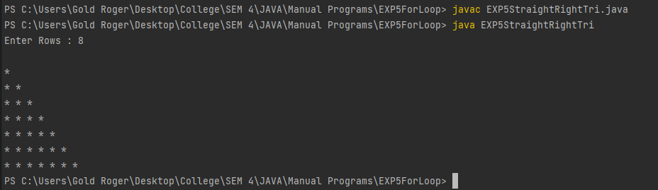

**8) WAP in JAVA to print upside-down right angled triangle via ‘*’**

**CODE:**

import java.util.Scanner;

public class EXP5UltaRightTri {

public static void main(String[] args) {

Scanner sc = new Scanner(System.in);

System.out.print("Enter Rows : ");

int rows = sc.nextInt();

for(int i = 0; i<=rows; i++) {

for (int j = rows; j>i; j--) {

System.out.print("* ");

}

System.out.println();

}

}

}

**OUTPUT:**

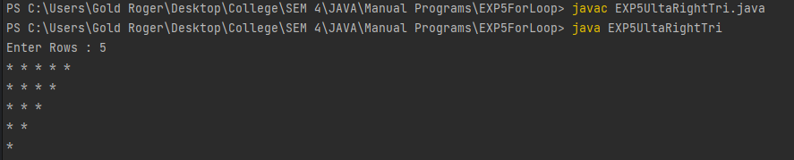

**9) WAP in JAVA to print upside-down right angled triangle via numbers**

**CODE:**

import java.util.*;

public class EXP5numTri {

public static void main(String[] args){

Scanner sc = new Scanner(System.in);

System.out.print("Enter number of rows:");

int op = sc.nextInt();

for(int i = 1 ; i<=op ; i++){

for(int j = 0 ; j<i ; j++ ){

System.out.print(i);

}

System.out.println(" ");

}

}

}

**OUTPUT:**

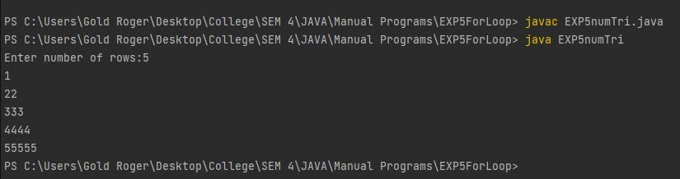

**10) WAP in JAVA to print non incrementing column right angled triangle via numbers**

**CODE:**

import java.util.*;

public class EXP5numTri2 {

public static void main(String args[]){

System.out.print("Enter number of rows:");

Scanner sc = new Scanner(System.in);

int rows = sc.nextInt();

for (int i = 1; i <= rows; ++i) {

for (int j = 1; j <= i; ++j) {

System.out.print(j + " ");

}

System.out.println();

}

}

}

**OUTPUT:**

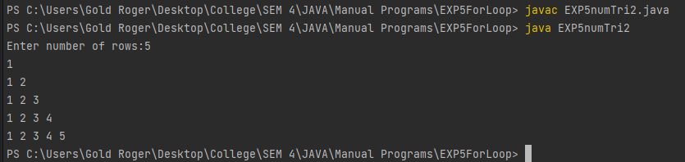

**11) WAP in JAVA to straight pyramid**

**CODE:**

import java.util.*;

class EXP5StraightPyramid {

public static void main(String[] args) {

int rows = 5, k = 0;

for (int i = 1; i <= rows; ++i, k = 0) {

for (int space = 1; space <= rows - i; ++space) {

System.out.print(" ");

}

while (k != 2 * i - 1) {

System.out.print("* ");

++k;

}

System.out.println();

}

}

}

**OUTPUT:**

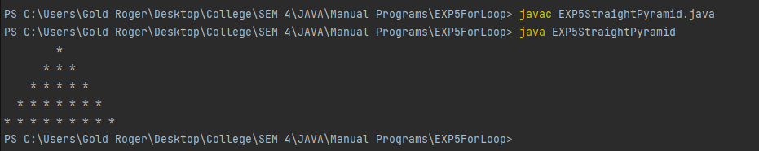

**12) WAP in JAVA to upside-down pyramid**

**CODE:**

import java.util.*;

class EXP5UltaPyramid {

public static void main(String[] args) {

int rows = 5;

for(int i = rows; i >= 1; --i) {

for(int space = 1; space <= rows - i; ++space) {

System.out.print(" ");

}

for(int j=i; j <= 2 * i - 1; ++j) {

System.out.print("* ");

}

for(int j = 0; j < i - 1; ++j) {

System.out.print("* ");

}

System.out.println();

}

}

}

**OUTPUT:**

